**DAILY ONLINE ACTIVITIES SUMMARY**

|  |  |  |  |  |  |  |  |  |
| --- | --- | --- | --- | --- | --- | --- | --- | --- |
| **Date:** | **28-05-2020** | | | | | **Name:** | **Shiza Amreen.J** | |
| **Sem & Sec** | **4th sem B sec** | | | | | **USN:** | **4AL18CS078** | |
| **Online Test Summary** | | | | | | | | |
| **Subject** | | **1.Microcontrollers And Embedded System**  **2. Aadalitha Kannada** | | | | | | |
| **Max. Marks** | | **1.20**  **2.50** | | **Score** | | | **1.19**  **2.26** | |
| **Certification Course Summary** | | | | | | | | |
| **Course** | **Python for Machine Learning** | | | | | | | |
| **Certificate Provider** | | | **GreatLearning** | | **Duration** | | | **5 Hours** |
| **Coding Challenges** | | | | | | | | |
| **Problem Statement:**   1. [C program to find digital root of a number](https://github.com/orgs/alvas-education-foundation/teams/2nd-year/discussions/84) 2. [In an array X of size M where the array elements contain values from 1 to M with duplicates, the task is to find total number of sub arrays which start and end with the same element.](https://github.com/orgs/alvas-education-foundation/teams/2nd-year/discussions/85) | | | | | | | | |
| **Status: Completed** | | | | | | | | |
| **Uploaded the report in Github** | | | | | **yes** | | | |
| **If yes Repository name** | | | | | **Lockdown_Coding** | | | |
| **Uploaded the report in slack** | | | | | **yes** | | | |

Online Test Details:

1. Today, in the morning, I had Microcontrollers and Embedded System IA-2, I have attended the test and scored 19 out of 20. 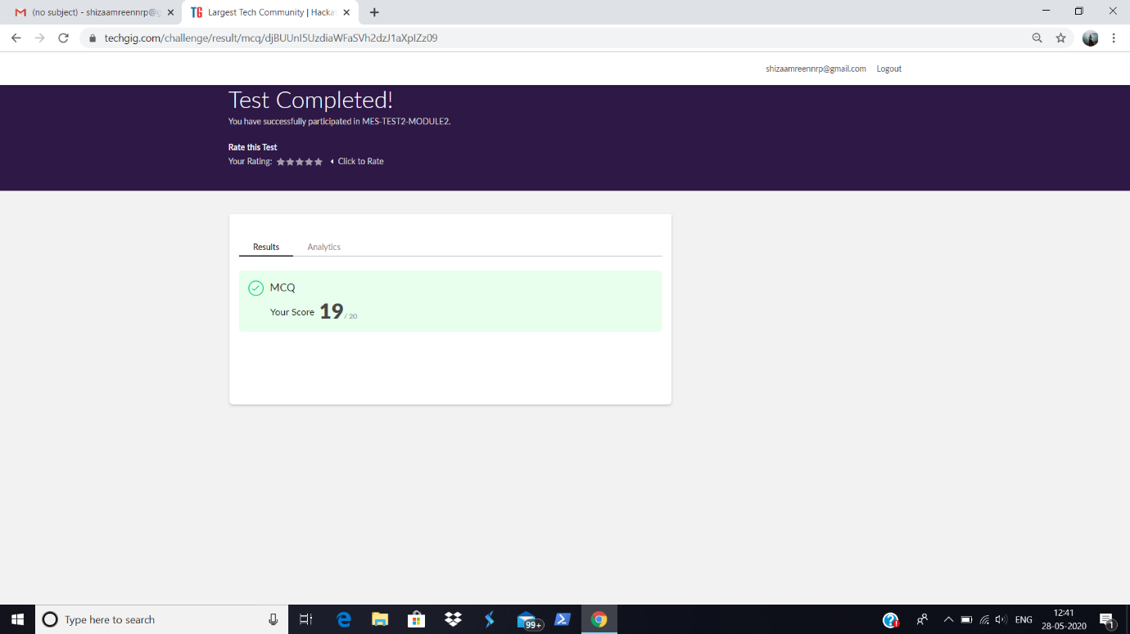

2. In the afternoon, I had Aadalitha Kannada IA, I have attended the test and got 26 out of 50.

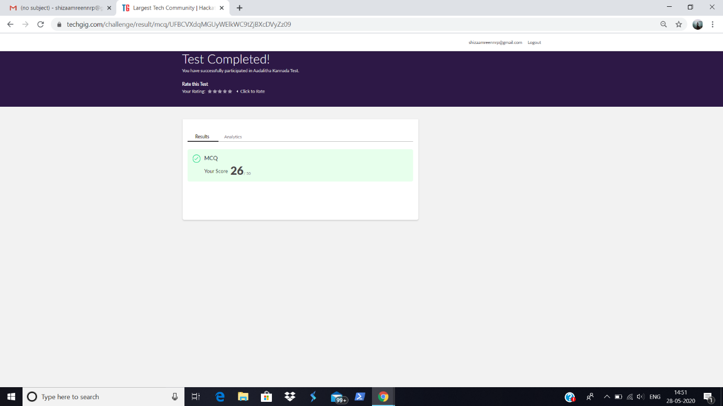

Certification Course Details:

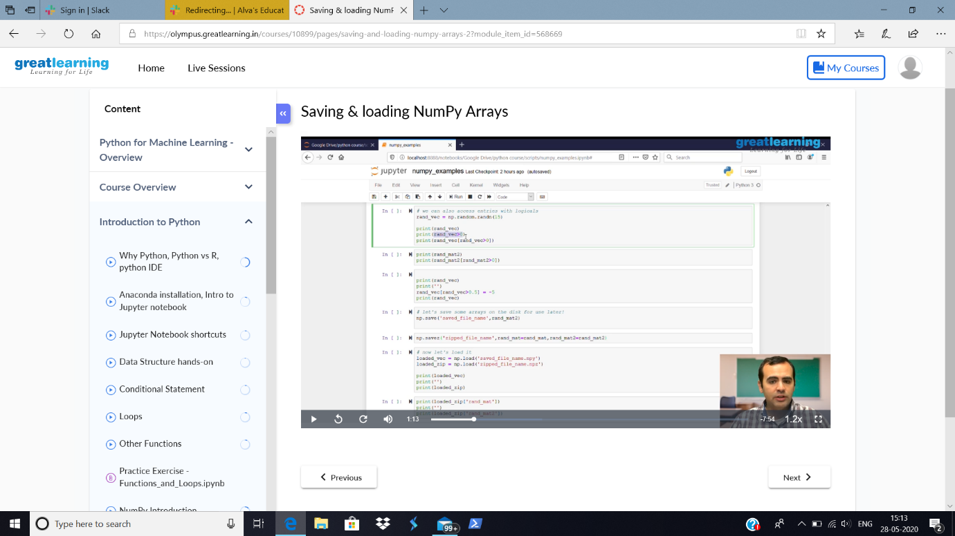

Today in Python for Machine Learning course, I have gone through the concepts of Saving and Loading Numpy Arrays.

Coding Challenges Details:

**Problem Statement:**

1. [C program to find digital root of a number](https://github.com/orgs/alvas-education-foundation/teams/2nd-year/discussions/84)
2. [In an array X of size M where the array elements contain values from 1 to M with duplicates, the task is to find total number of sub arrays which start and end with the same element.](https://github.com/orgs/alvas-education-foundation/teams/2nd-year/discussions/85)

I have written the code for given problem statements and uploaded it in my github repository, named Lockdown_Coding.

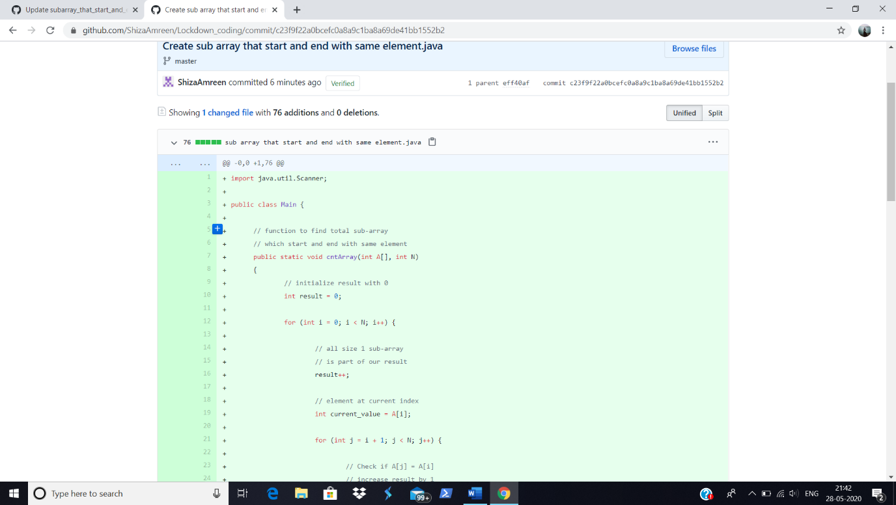

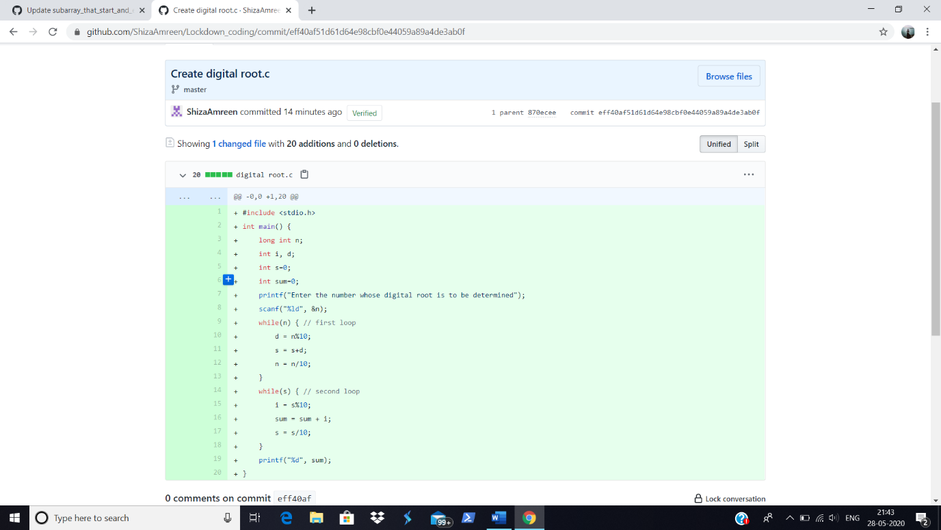

<https://github.com/ShizaAmreen/Lockdown_coding>